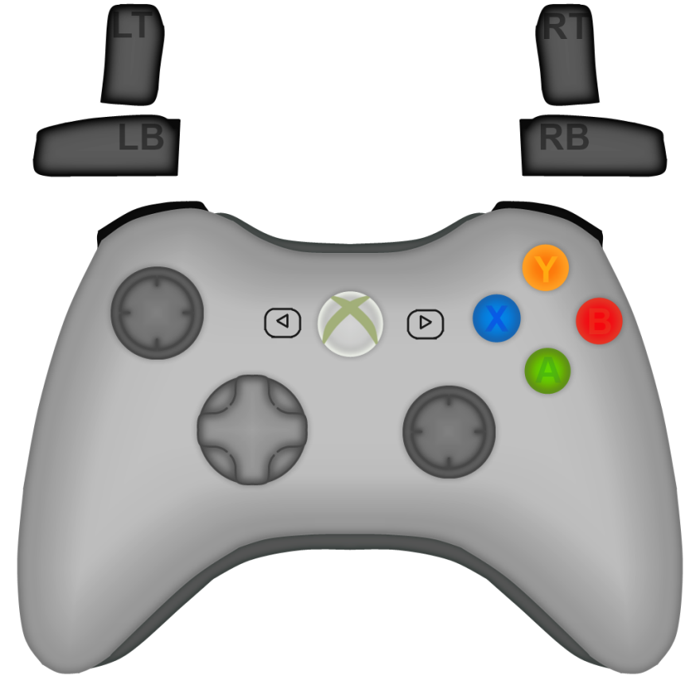

|  |  |  |  |
| --- | --- | --- | --- |
| Driving Controls 20## | | | |
| Movement | | Mechanics | |
| Left Joystick |  | Left Joystick |  |
| A |  | A |  |
| B |  | B |  |
| Y |  | Y |  |
| X |  | X |  |
| Right Joystick |  | Right Joystick |  |
| Left Bumper |  | Left Bumper |  |
| Left Trigger |  | Left Trigger |  |
| Right Bumper |  | Right Bumper |  |
| Right Trigger |  | Right Trigger |  |
| D-Pad |  | D-Pad |  |
| Start (|>) |  | Start (|>) |  |
| Back (<|) |  | Back (<|) |  |
| X-Box Button |  | X-Box Button |  |